# Day- 3 | SQL | WHERE Clause

## The SQL WHERE Clause

1. The WHERE clause is used to filter records.
2. It is used to extract only those records that fulfill a specified condition.

### Example:

Select all customers from Mexico:

SELECT **\*** FROM Customers WHERE Country='Mexico'; (Vs)

SELECT **CustomerName** FROM Customers WHERE Country = 'Mexico';

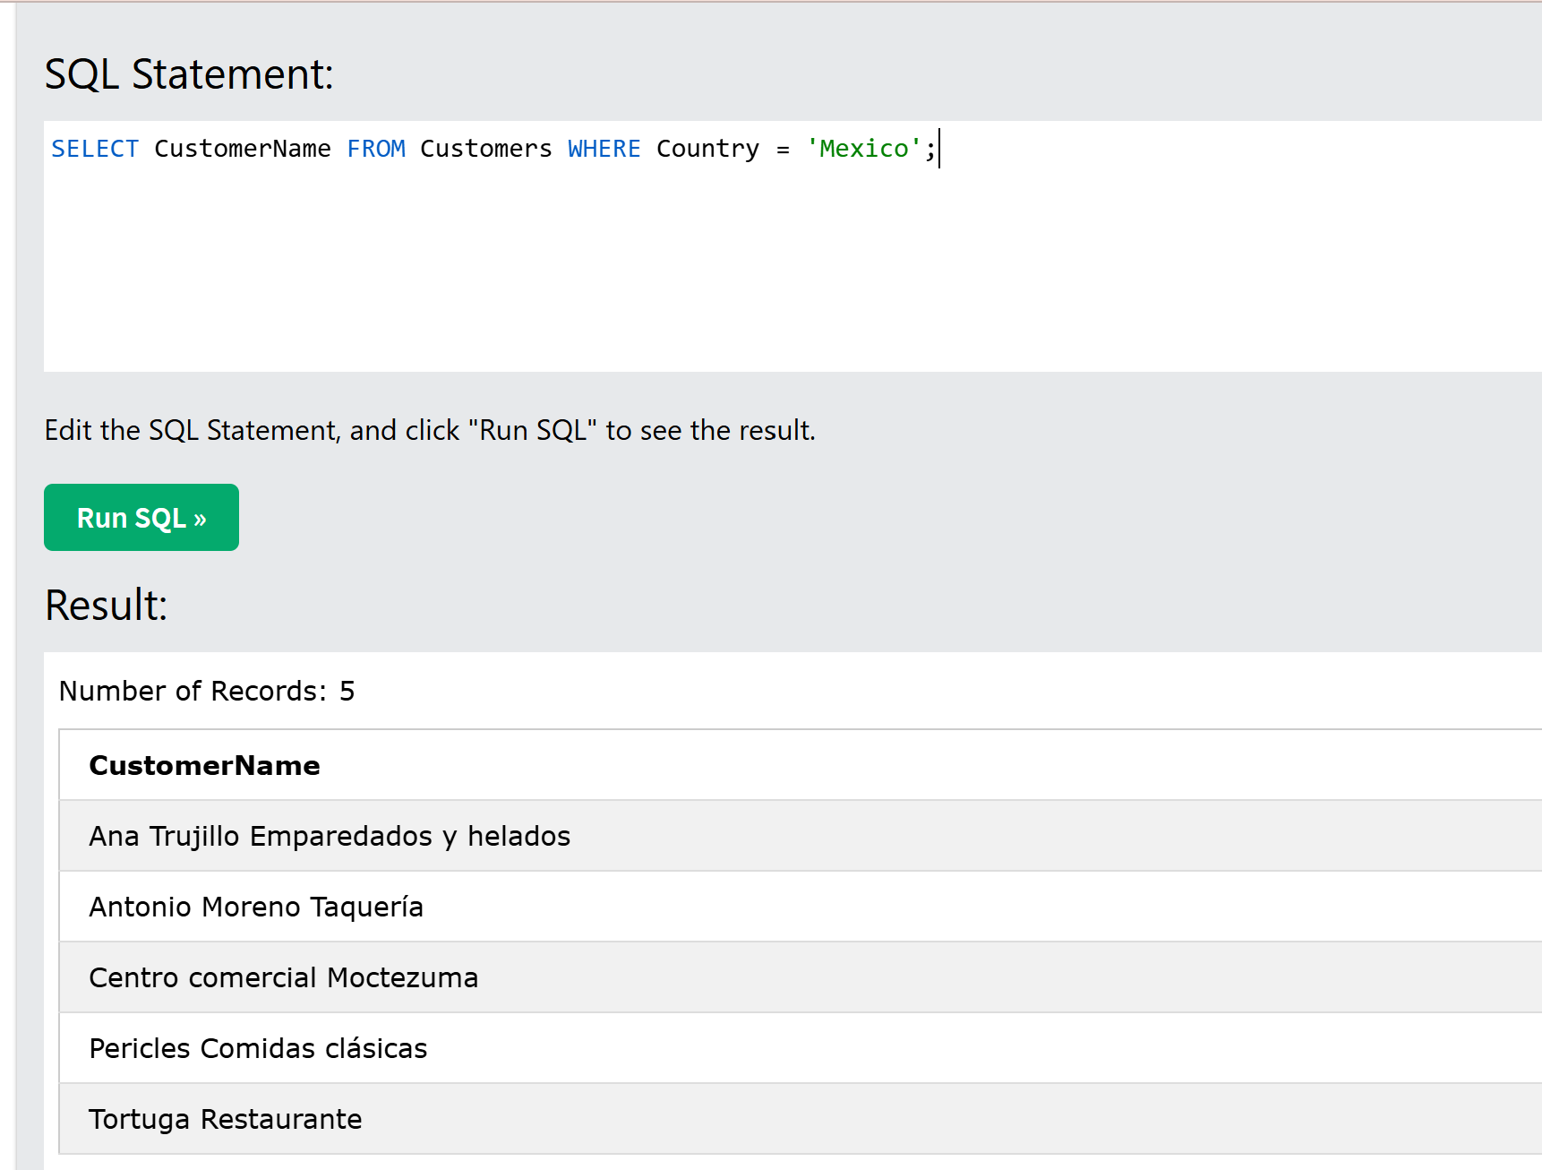

# 

## Syntax: SELECT column1, column2, ... FROM table_name WHERE condition;

**Note:** The WHERE clause is not only used in SELECT statements, it is also used in UPDATE, DELETE, etc.!( If you don’t know about Delete and update don’t’ worry about it)

## Text Fields vs. Numeric Fields

SQL requires single quotes around text values (most database systems will also allow double quotes). However, numeric fields should not be enclosed in quotes:

Quotes: ‘—‘

### Example: SELECT * FROM Customers WHERE CustomerID=1;

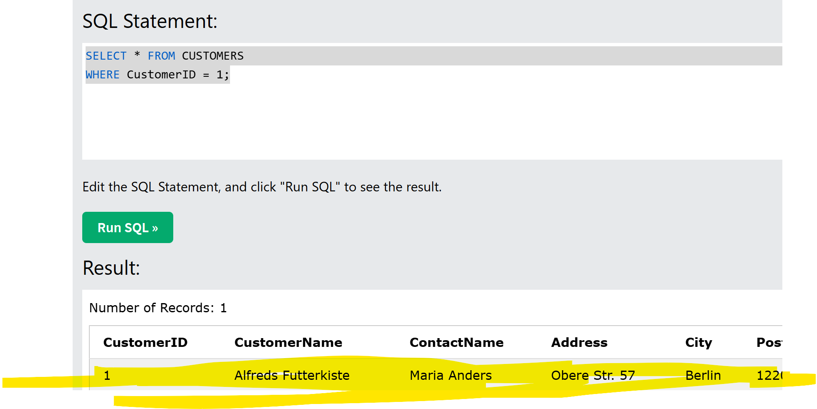

## Operators in The WHERE Clause

You can use other operators than the = operator to filter the search.

**Example:** Select all customers with a CustomerID greater than 80:

### SELECT * FROM Customers WHERE CustomerID > 80;

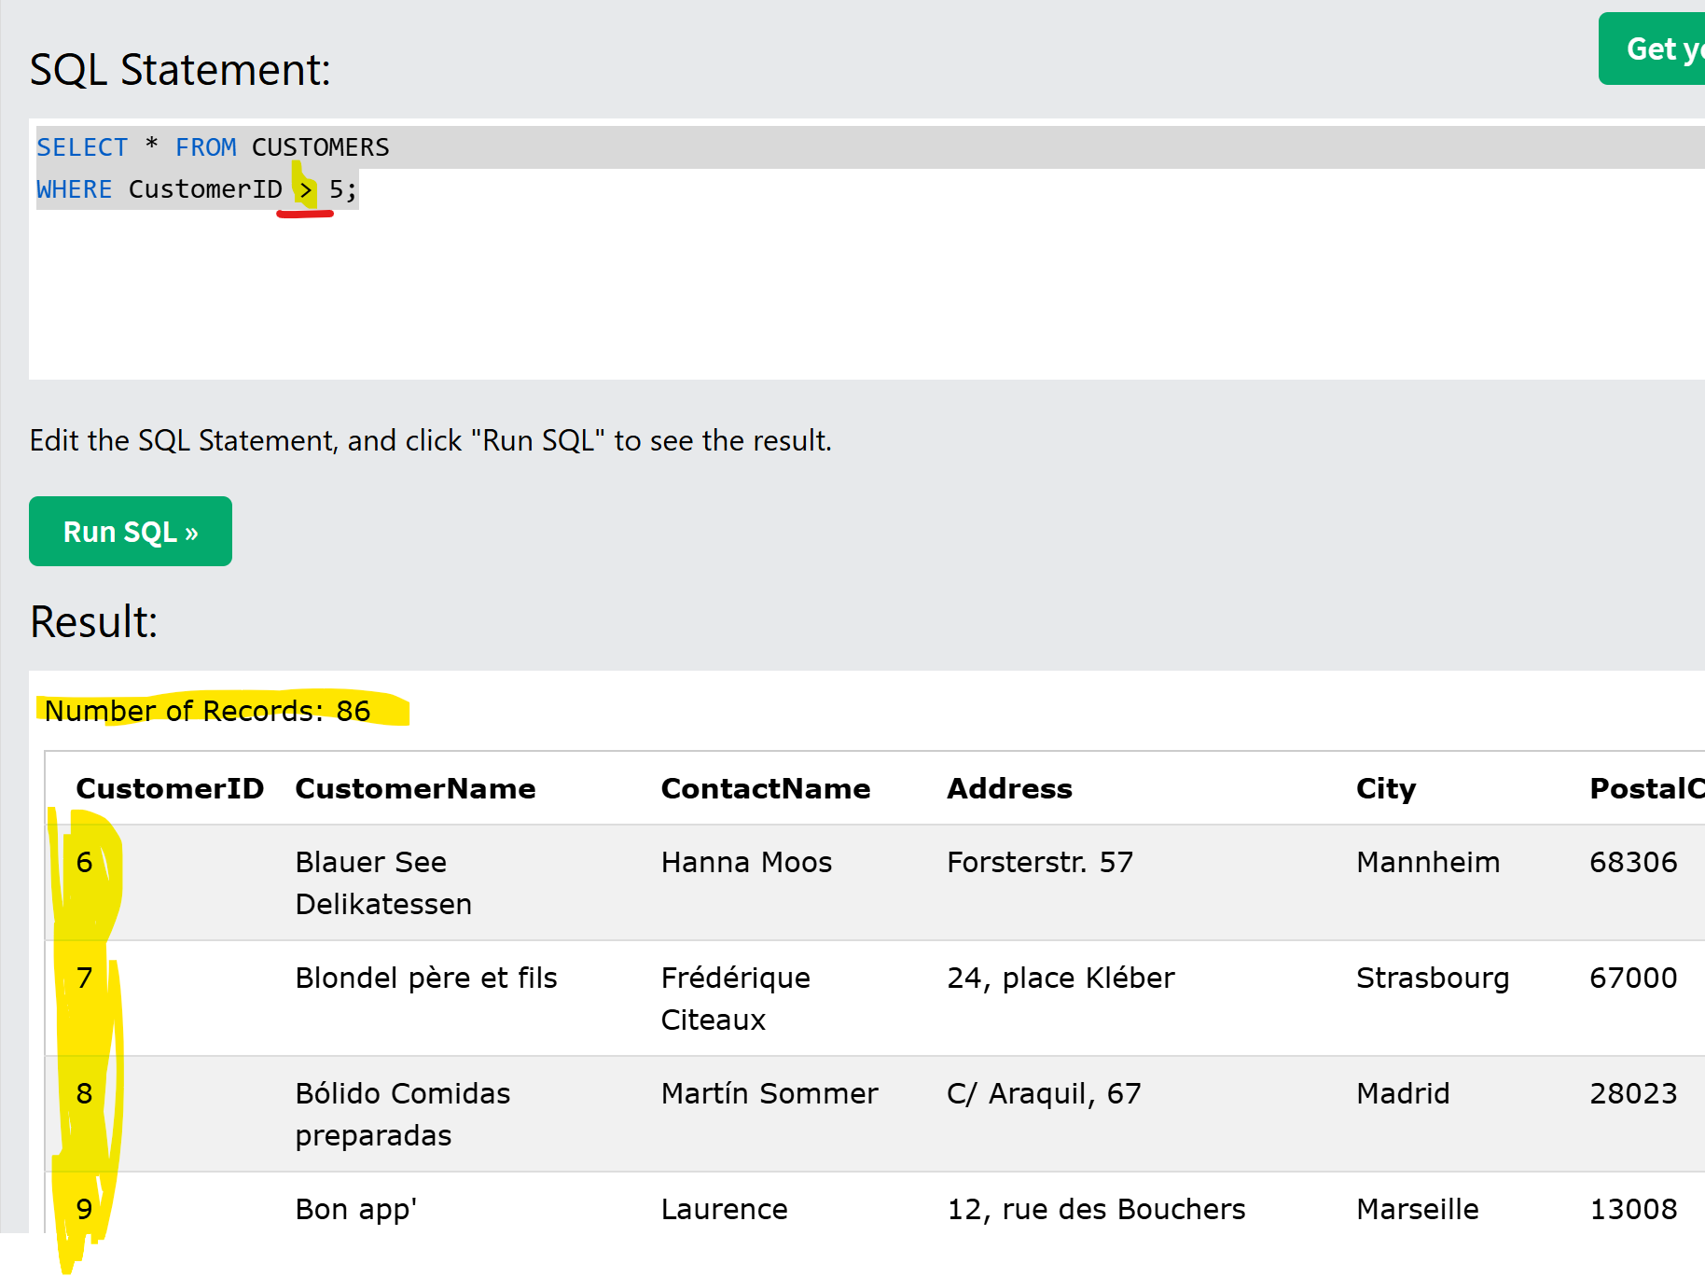

**The following operators can be used in the WHERE clause:**

# 

# 

# Answer: 2

# 

# Answer: 2

# Answer: Select * from Customers where city = ‘ Berlin’;

# 

# Answer: Select * from Customers where CustomerID = 32;

# 

# Answer: 2

# 

# Answer: SELECT * FROM CSUTOMERS

# Where CustomerID > 50;

# 